**“Advanced JUnit Testing Exercises”**

**Exercise 1: Parameterized Tests Scenario: You want to test a method that checks if a number is even. Instead of writing multiple test cases, you will use parameterized tests to run the same test with different inputs.**

***SOLUTION:***

**1.EvenChecker.java**

package Utilities;

public class EvenChecker {

public static boolean isEven(int number) {

return number % 2 == 0;

}

}

**2.EvenCheckerTest.java**

package Utilities;

import org.junit.jupiter.params.ParameterizedTest;

import org.junit.jupiter.params.provider.ValueSource;

import static org.junit.jupiter.api.Assertions.*;

public class EvenCheckerTest {

@ParameterizedTest

@ValueSource(ints = {2, 4, 6, 8, 10, 100})

void testIsEvenWithEvenNumbers(int number) {

*assertTrue*(EvenChecker.*isEven*(number), number + " should be even");

}

@ParameterizedTest

@ValueSource(ints = {1, 3, 5, 7, 9, 99})

void testIsEvenWithOddNumbers(int number) {

*assertFalse*(EvenChecker.*isEven*(number), number + " should be odd");

}

}

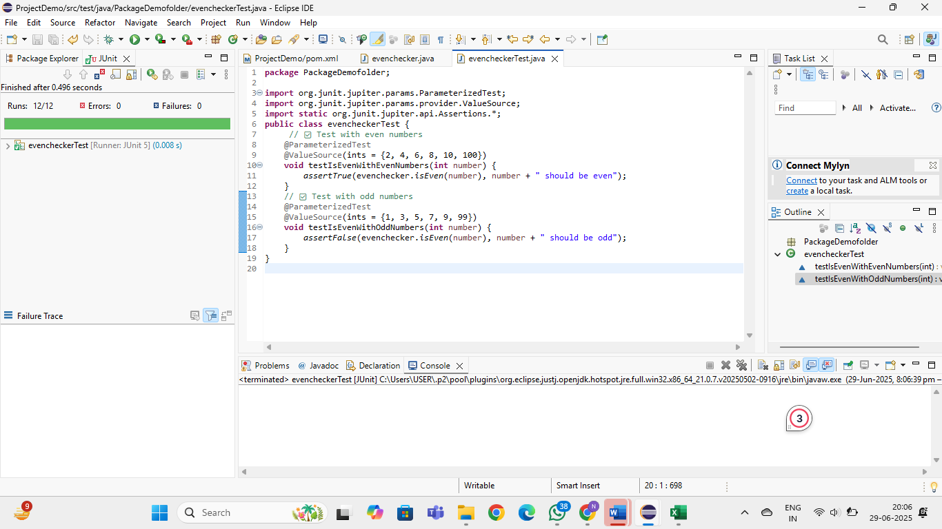

**---------------------------------------------------------------------------------------------------------------------------**

**Exercise 2: Test Suites and Categories , Scenario: You want to group related tests into a test suite and categorize them.**

***SOLUTION:***

**1.MathTest.java**

package Utilities;

c

**2.StringTest.java**

package Utilities;

import org.junit.jupiter.api.Test;

import static org.junit.jupiter.api.Assertions.*;

public class StringTest {

@Test

void testUpperCase() {

*assertEquals*("HELLO", "hello".toUpperCase());

}

@Test

void testLength() {

*assertEquals*(4, "test".length());

}

}

**3.AllTests.java**

package Utilities;

import org.junit.platform.suite.api.SelectClasses;

import org.junit.platform.suite.api.Suite;

@Suite

@SelectClasses({

MathTest.class,

StringTest.class

})

public class AllTests {

// No code needed; this class acts as a suite holder

}



